**Gantt Chart Overview**

The Gantt chart in **figure 3** breaks down the project development process of the Personalized Travel Plan Generator into a timeline of tasks across several weeks.

**Project Phases and Timeline:**

1. **23/3/2025**: Requirement Gathering and Planning, UI Design and Prototyping.
2. **13/4/2025**: detailed design(System Architecture, Class-Diagrams, Design patterns ER diagram).
3. **18/5/2025**: Frontend and backend deployment and Testing
4. **25/5/2025**: : Discussion and presentation

Refer to **Figure 3** for the detailed Gantt chart.

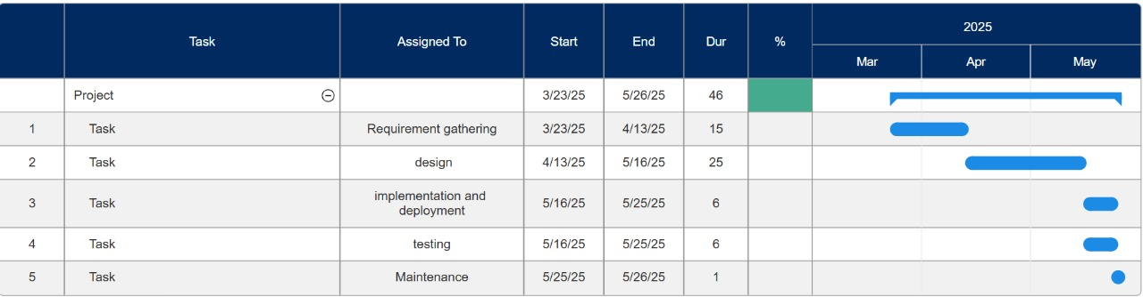

**Figure 3:** Gantt chart for Personalized Travel Plan Generator.